Phase 2: Innovation

Consider integrating historical traffic data and machine learning algorithms to predict congestion patterns.

What is traffic prediction, who needs it, and why is it important?
Traffic prediction means forecasting the volume and density of traffic flow, usually for the purpose of managing vehicle movement, reducing congestion, and generating the optimal (least time- or energy-consuming) route.
Traffic prediction is mainly important for two groups of organizations (we’re not talking about folks planning a weekend getaway, you know).
1.National/local authorities
In the last ten to twenty years, many cities adopted intelligent transportation systems (ITS) that support urban transportation network planning and traffic management. These systems use current traffic information as well as generated predictions to improve transport efficiency and safety by informing users of current road conditions and adjusting road infrastructure (e.g., street lights).

Logistics companies
Another area of implementation is the logistics industry. Transportation, delivery, field service, and other businesses have to accurately schedule their operations and create the most efficient routes. Often, it’s not only related to current trips, but also to activities in the future. Precise forecasts of road and traffic conditions to avoid congestion are crucial for such companies’ planning and performance.
So, how is traffic predicted?
As of today, different machine learning (and specifically deep learning) techniques capable of processing huge amounts of both historic and real-time data are used to forecast traffic flow, density, and speed. We’ll describe some effective algorithms further on. But first, we’ll look into what data is needed for traffic prediction and where you can get it from.
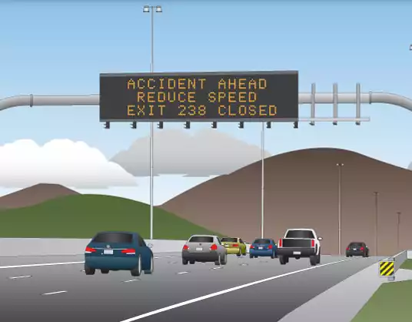
Road related speed management involves ensuring that drivers and riders adopt safe speeds through engineering and speed limits.
Regulating traffic speed to levels commensurate with the road environment is crucial to the delivery of forgiving roads. To build a safe road system and to reduce deaths and serious injuries, the human body’s tolerance to impact forces should be used as a guiding tool. Impact speeds for different vehicle crash types after which the risk of death escalates are:
- 70 km/h head-on impact
- 50 km/h side impact
- 30 km/h side impact with objects
- 30 km/h impact with pedestrians, bicyclists and motorcyclists.

Data types and sources
Traffic is influenced by many factors, and you should consider all of them to make accurate predictions. So, there are several main groups of data that you’ll have to obtain.
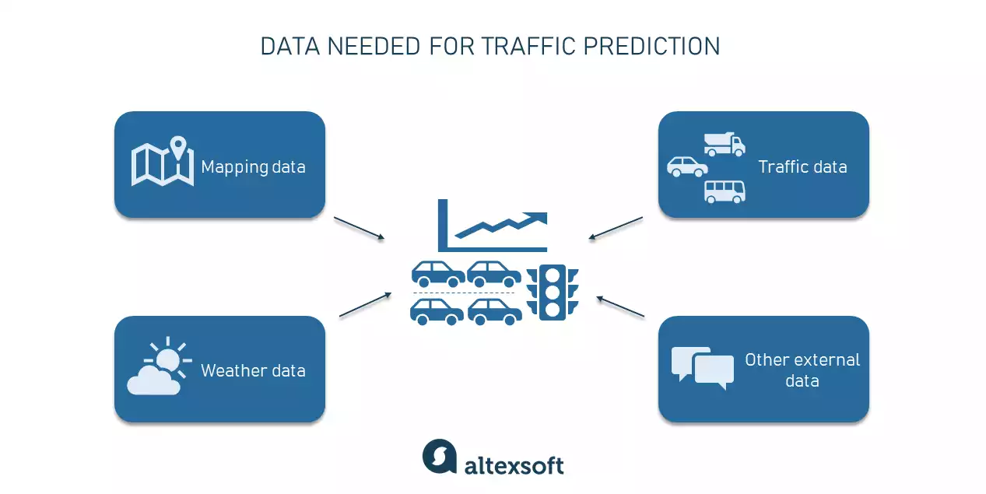

Mapping data
First of all, you need to have a detailed map with road networks and related attributes. Connecting to such global mapping data providers as Google Maps, TomTom, HERE, or OSM is a great way to obtain complete and up-to-date information.
Traffic information
Then, you’ll have to collect both historical and current traffic-related information such as the number of vehicles passing at a certain point, their speed, and type (trucks, light vehicles, etc.). Devices used to collect this data are
- loop detectors,
- cameras,
- weigh in motion sensors, and
- radars, or other sensor technologies.
Fortunately, you don’t have to install these devices all over the place on your own. It’s easier to get this information from the aforementioned providers that gather data from a system of sensors, diverse third-party sources, or make use of GPS probe data. (Just in case you’re unfamiliar with how infrastructures for collecting, processing, and storing data are designed and work.Other platforms such as Otonomo use an innovative Vehicle to Everything (V2X) technology to collect so-called connected car data from embedded modems.You can also get other important information on incidents (road closures or roadworks), places of interest, etc., from data providers.
Weather information
Weather data (historical, current, and forecasted) is also necessary as meteorological conditions impact the road situation and driving speed. There are lots of weather data providers you can connect to — such as OpenWeather or Tomorrow.io.
Additional data on road conditions
There are external data sources that can provide important information that impacts traffic. Think social media posts about sports events in the area, local news about civil protests, or even police scanners about crime scenes, accidents, or road blockages.
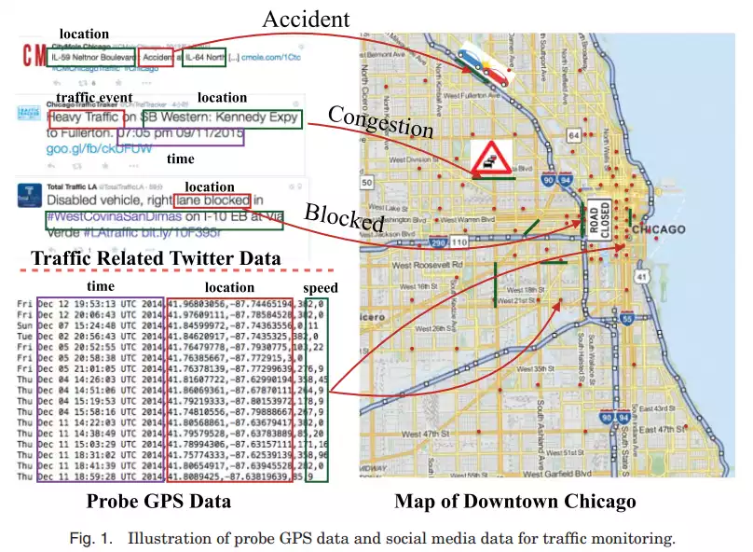
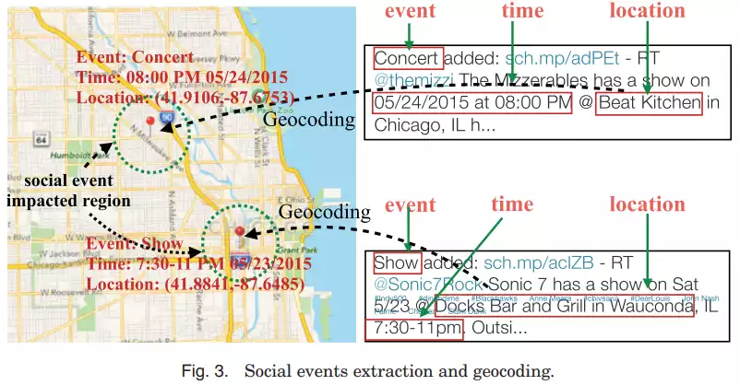

Algorithms for generating traffic predictions
Traffic prediction involves forecasting drivable speed on particular road segments, as well as jam occurrence and evolution. Let’s take a look at different approaches to this task.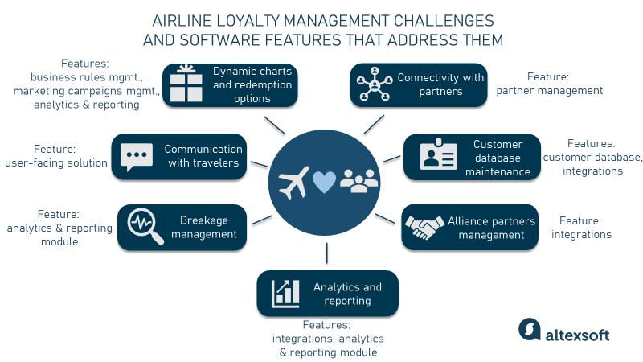

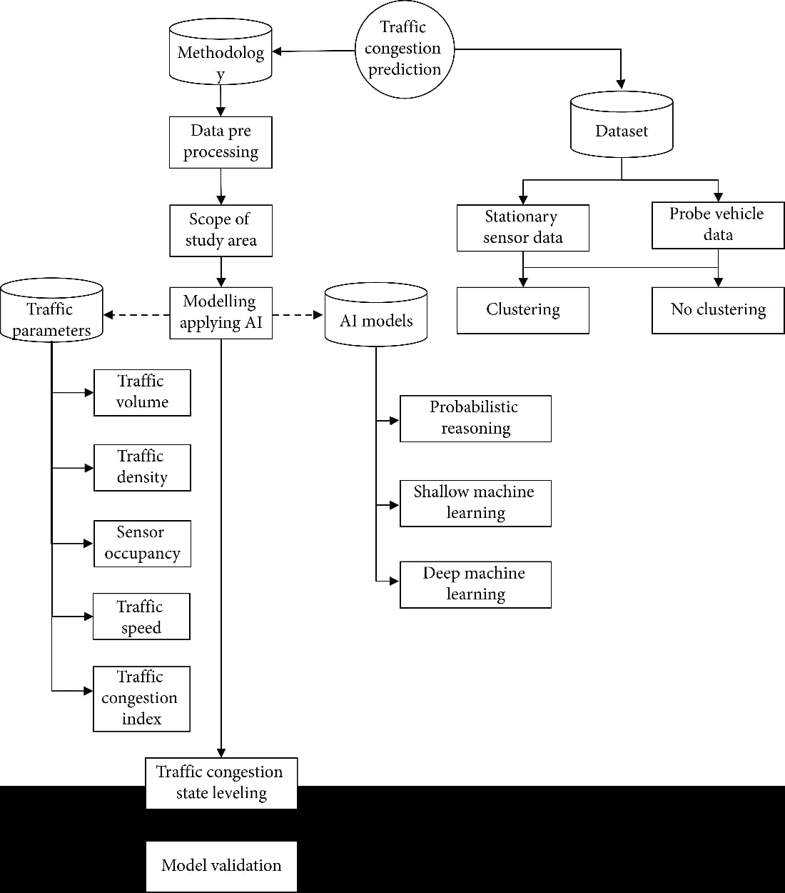Statistical approach
Statistical methods allow you to identify traffic patterns at a different scale: during the day, on different days of the week, seasonal, etc. They are usually easier, faster, and cheaper to implement than machine learning ones. However, they are less accurate since they can’t process as much multivariate data.
Specifically, auto-regressive integrated moving average (ARIMA) models have been actively used to predict traffic since the 1970s as they are easy to implement and show higher accuracy compared to other statistical methods. It’s a classical statistical approach to analyzing past events and predicting future ones. It observes data that is collected from a series of regular time intervals and assumes that past patterns will repeat in the future.

However, traffic flow is a complex structure with many variables that can’t be effectively processed with the help of the univariate ARIMA models.

Machine learning approach
Machine learning (ML) allows you to create predictive models that consider large masses of heterogeneous data from different sources. Numerous studies have been conducted on the application of ML algorithms to forecast road traffic. Here are some successful examples.
The random forest algorithm creates multiple decision trees and merges their data to obtain accurate predictions. It’s quite fast and can produce effective results given sufficient training data. When applied to the road congestion problem, this method showed an accuracy of 87.5 percent. In this case, weather conditions, time period, special conditions of the road, road quality, and holidays are used as model input variables.
The k-nearest neighbors (KNN) algorithm relies on the principle of feature similarity to predict future values. Experiments with the KNN model demonstrated over 90 percent accuracy of short-term traffic flow prediction.

Deep learning approach
Deep learning (DL) methods have proved highly effective in predicting road traffic in comparison to ML or statistical techniques, consistently showing about 90 percent forecasting accuracy and higher. Deep learning algorithms are based on neural networks.
Neural networks (NN) or artificial neural networks (ANN) consist of interconnected nodes (neurons) that are arranged in two or more layers and are designed to function similar to the human brain. There are many types of neural networks developed for different purposes. Here are some that were used in traffic analysis and prediction.
Convolutional neural networks (CNNs) are trusted leaders in image recognition and analysis. One of their natural applications to transportation problems is congestion detection, using pictures from surveillance cameras on the road. The average accuracy of classification in this case reaches 89.5 percent. As for traffic predictions, CNNs are not the first choice. However, there were quite successful attempts to build CNN-based models forecasting transportation network speed. To make this happen, researchers converted time and space data describing traffic flow into a 2-dimensional image matrix.
Recurrent neural networks (RNNs), by contrast with CNNs, are intended toprocess time-series data or observations collected over certain time intervals. Traffic patterns are a good example of such observations. Research showed high accuracy in predicting congestion evolution when applying RNN models. However, their drawback is the vanishing gradient issue which means that part of the data from previous layers gets lost (that’s why RNNs are said to “have a short-term memory”). This “forgetfulness” makes model training more difficult and time-consuming.
How to implement traffic prediction
If you run a logistics business, most likely you don’t need traffic prediction by itself, but rather its impact on your operations. As we’ve already mentioned, accurate prediction is important for routing and scheduling purposes. If this is the case, there are three main ways to get those forecasts and build optimal routes (check our related article for more ideas and information).

Off-the-shelf solutions
There are lots of ready-made software solutions on the market developed for any type of business. If your company is small or medium-sized and your operations (be it field service, last-mile delivery, taxi, moving, or long-haul transportation) are more or less standardized, you can find a tool that meets your needs and has routing capabilities to support your business activities.
OptimoRoute, Fixlastmile, Badger Maps, Route4Me, or Routific – a myriad of platforms offer route planning and optimization functionality (especially in the short-term perspective). The choice depends on your industry and specific business demands.
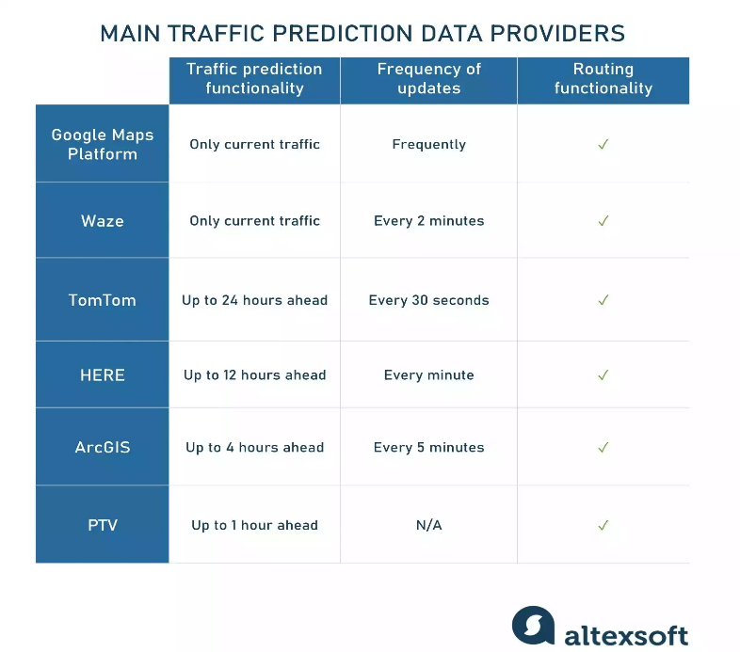
Another option is exploiting the traffic predicting functionality of external platforms. In this case, you keep using your own system that fits your needs and that your staff is used to, and at the same time avoid the complex process of ML model building, training, evaluation, and so on. To make it happen, you’ll have to build an API integration with traffic data providers. Here are some options.

Google Maps Platforms. If you want to partner with the biggest mapping data provider, keep in mind: you’ll only be able to add the current traffic layer to your map, but no forecasts. Moreover, their documentation warns: “Traffic information is refreshed frequently, but not instantly. Rapid consecutive requests for the same area are unlikely to yield different results.” They also offer a diverse suite of APIs to add their map or routing functionality to your location-based product.
Waze. Another Google product and second most popular navigation app gets information on traffic, accidents, jams, and other road conditions only from their users driving around. The information is updated every 2 minutes and can be accessed via localized XML and JSON Geo RSS data feeds. Note, that this information will be reliable only if there is a sufficient number of drivers in the area. You can also embed Waze Live Map with search and routing functionality on your website. As for predictions, the app doesn’t make and provide any.
TomTom. TomTom’s Traffic RESTful APIs give access to historical and real-time data related to traffic incidents and flow. TomTom makes use of over 600 million GPS and floating car data probes to collect up-to-date information (updated every 30 seconds), analyze it, and make predictions up to 24 hours ahead. You can leverage this data to create routes with your own app or get their comprehensive routing product.
HERE. HERE Real-Time Traffic platform collects data from more than 100 incident reporting services and utilizes billions of GPS data points daily. Its data is updated every minute. HERE provides real-time information and creates accurate predictions for the next 12 hours based on historical and current traffic data. Check their Traffic RESTful API documentation for details.
ArcGIS. ArcGIS Traffic service REST APIs allow you to get traffic conditions visualized in your app. Traffic data is updated every 5 minutes and predictions for the next 4 hours are available. In addition, the web map provides information about the incidents
PTV. PTV Traffic Data and PTV Data Analytics Platform support their own mapping and routing products (e.g., PTV Optima) and can be connected to in order to get historical and real-time traffic information as well as short-term forecasts (up to 60 minutes ahead). Visit their Traffic Information API page for integration details or Digital Map API page if you need additional map content (for example, truck-specific restrictions).

